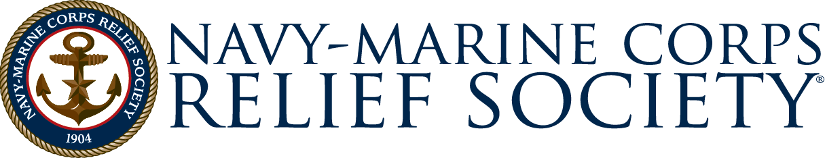

Pre-Authorization Form

From:
(Service Member Last Name, First Name, and Middle Initial)
SSN: |  |  |  |  |  |  |  |  |  | Rate/Rank |  |  |  |  |  |  | EAS
Military Address:
To: |  |  |  |  |  |  |  |  |  |  | Navy-Marine Corps Relief Society
(NMCRS Office Location)
Subj: Authorization for Assistance to Eligible Family Members
- During the period I am deployed I authorize
to receive necessary financial assistance without my specific approval.
 |  | Authorization valid between |  |  |  |  |  |  |  |  |  |  |  |  | and
 |  |  |  |  |  |  |  |  |  |  |  | (not to exceed 12 months)
 |  | Amount authorized:
 |  |  |  |  |  |  |  |  |  |  |  | (not to exceed $3,000.00)
- I understand that I will be responsible for repayment, if warranted, of such assistance. Further, if the assistance is provided as a no-interest loan, I authorize Navy-Marine Corps Relief Society (NMCRS) to start an allotment for the amount of the loan. Allotment terms are based on the best information available to NMCRS at the time of the loan. Further, I understand that it will be the responsibility of the family member using this Pre- Authorization to provide me with notification concerning any assistance provided based on it, along with information pertaining to the terms of any allotment started.
- I understand that any assistance to my eligible family members will depend on the merits of the situation and the policies of the Navy-Marine Corps Relief Society. I also understand that this authorization does not establish a line of credit at the Navy-Marine Corps Relief Society.
- I hereby authorize Navy-Marine Corps Relief Society to have access to my personal and pay information for the purpose of processing a request for assistance to include DEERS verification.
Signed: |  |  |  |  |  |  |  |  |  |  |  |  |  |  |  | Date:
 |  |  | (Service Member’s Signature)
Witness: |  |  |  |  |  |  |  |  |  |  |  |  |  |  |  | Date:
(Signature of Command Representative or NMCRS Representative)
Title:
Unit/Office:

